# CS 255 System Design Document – Kirsten Skouri

## UML Diagrams

### UML Use Case Diagram

### UML Activity Diagrams

Registration:

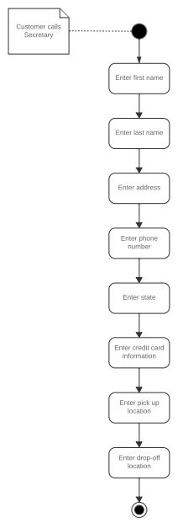

Make Appointments:

### UML Sequence Diagram

Registration:

### UML Class Diagram

## Technical Requirements

The technical requirements for the system include hardware, a database, security, an operating system, and updates. Employees will need computers to access the system to complete their necessary tasks and drivers need mobile devices to allow them to take notes during lessons. The system will need a database to store the data that the owner wishes to track and access. The system should run over the cloud to provide backup and security and needs secure access by requiring login information and passwords. An up-to-date operating system is needed to create a quality system that keeps up with current technology and a connection with the DMV is needed to provide updates, which will take place overnight when the system is being used the least.